LINEAR PROGRAMMING

Programming ≡ 3. Providing (a computer) with a set of instructions for

solving a problem
American Heritage Dictionary

Algorithm ≡ a step-by-step procedure, usually for solving a problem

Linear programming ≡ Providing an algorithm for solving a linear

decision problem of the form:

Max/Min 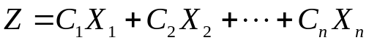

s.t. 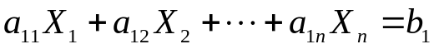
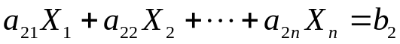

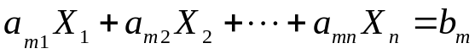

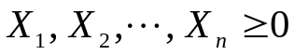

Equivalently
Max Z= C^{T}X
Subject to Ax=b
x≥0.

George Dantzig – Developed “simplex” algorithm for LP
(first publication in 1947)

Directed US Air Force Project SCOOP (late 40’s – early 50’s)

(Scientific Computation Of Optimal Programs)

devising new LP algorithms and methods &

developing computer implementations
4 Basic Assumptions:

Proportionality: The contribution of the objective function from each decision variable is proportional to the value of that variable. (Nonexample: candy bars, fixed ordering costs)

Additivity: The contribution of the objective function for any variable is independent of the values of the other decision variables
(Nonexample: grocery stores cereal and milk)

Divisibility: Each decision variable can have fractional numbers.
(Nonexample: people, parts) Example: lots of people or parts.

Certainty: Each data parameter (A, C, b) are certain and unchanging.
(Nonexample: demand).

